**Disk Addition in ASM DG**

**Before Automation**

1. We Will login to the ASM instance and will check the candidate disk assigned recently

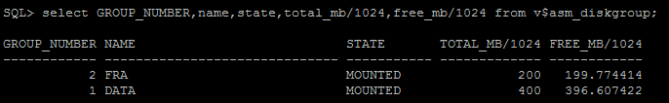

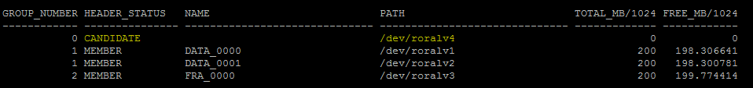

1. Add the candidate disks into ASM DG manually by using the below query,

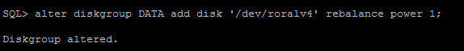

1. Check the DG size after adding the disks into ASM DG.

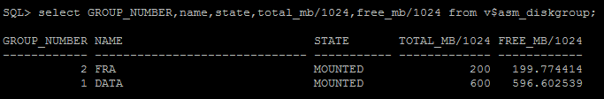

**After Automation**

1. Execute the below script to disks into ASM DG

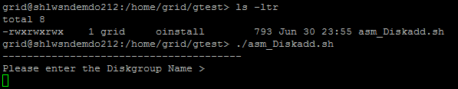

1. Enter the diskgroup name in which we want to add the disk

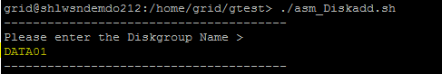

1. Enter the number of disks

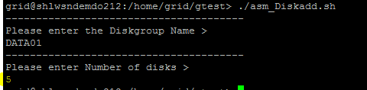

1. Once the script executed, It will generate a SQL file for adding the disks into ASM diskgroup

